## Generate E-R Model

create database student_mangement_schema;

use student_mangement_schema;

create table department(dept_id int primary key,dept_name varchar(45));

create table semester(sem_id int primary key,sem_name varchar(45),academic_year int);

desc semester;

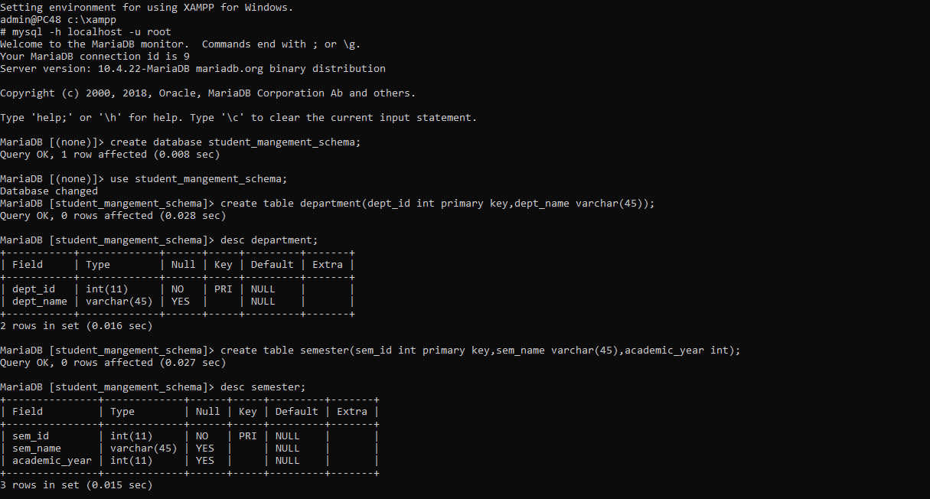

create table course_details(course_code int,course_name varchar(45),sem_id int,dept_id int,course_type varchar(45));

create table staffs(staff_id int primary key,sf_firstname varchar(45),sf_lastname varchar(45),designation varchar(45),academic_year int,staff_dob date,staff_dept_id int,staff_doj date,staff_experience float,staff_salary double);

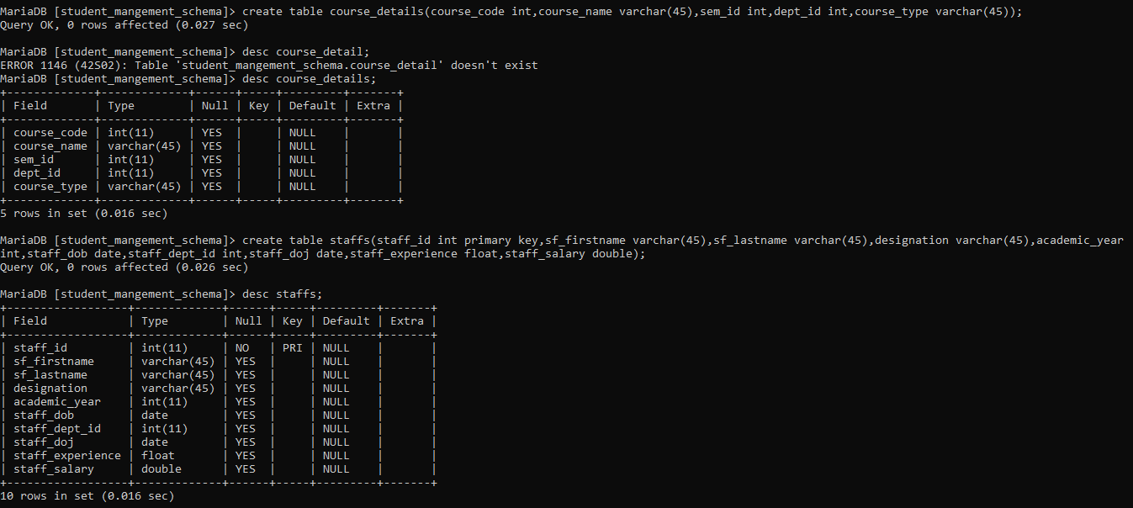

create table result_analysis(course_code int,pass_percentage float,staff_id int);

create table students(st_id int,st_fname varchar(45),st_lname varchar(45),dob date,join_date date,st_dept_id int,city varchar(45),zipcode int,staff_incharge_id int);

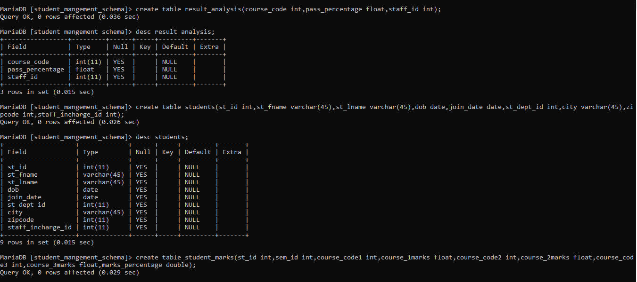

create table student_marks(st_id int,sem_id int,course_code1 int,course_1marks float,course_code2 int,course_2marks float,course_code3 int,course_3marks float,marks_percentage double);

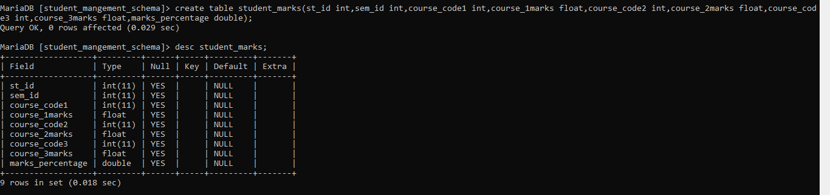

1. **Insert records**

Table-Department,semester

insert into department values('1', 'CSE'),('2', 'ME'),('3', 'EEE');

insert into semester VALUES ('1','CSE'),('2','ME'),('3','EEE');

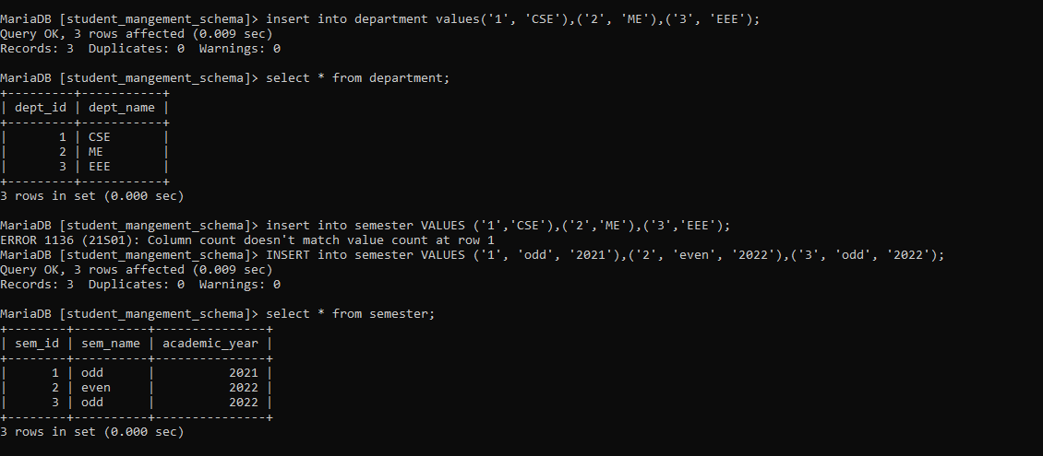

Table-CourseDetails,staffs

INSERT INTO course_details VALUES ('101', 'JAVA', '1', '1', 'Core'),('102', 'CadLabs', '2', '2', 'Regular'),('103', 'DSA', '2', '3', 'Elective');

INSERT INTO staffs VALUES ('1', 'Ankush ', 'Gaba', 'Associate ', '2021', '1999-08-08', '1', '2021-09-12', '3', '10000'),('2', 'Reena', 'Dhingra', 'Professor', '2018', '1998-07-23', '3', '2022-04-23', '5', '150000'),('3', 'Ram', 'Singh', 'Director', '2019', '1975-02-21', '2', '2015-07-22', '12', '250000');

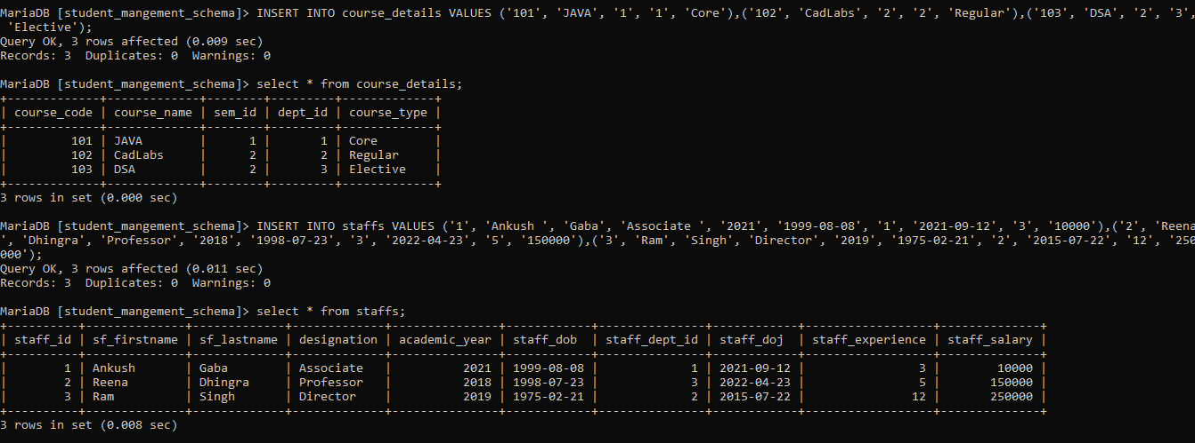

Table-Result_analysis

INSERT INTO result_analysis VALUES ('101', '33', '1'),('102', '34', '2');,('103', '35', '3');

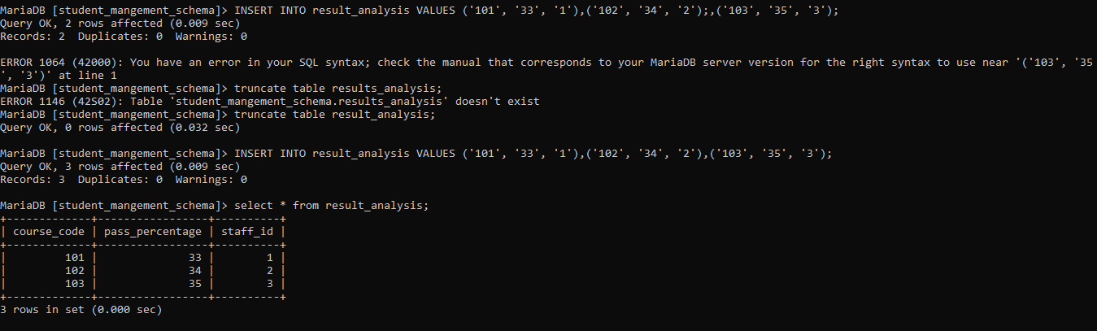

Table-Students,student_marks

INSERT INTO students VALUES ('1', 'Sohan', 'Sharma', '1996-08-18', '2021-07-28', '1', 'panipat', '132103', '1'),('2', 'Mohan', 'Dhingra', '1997-02-23', '2021-08-06', '2', 'Karnal', '132119', '2'),('3', 'Rohan', 'Verma', '1998-09-06', '2021-09-09', '3', 'Samalkha', '132101', '1');

INSERT INTO student_marks VALUES ('1', '1', '101', '47', '102', '68','103', '45', '50'),('2', '2', '102', '78', '103', '78','101', '64', '69'),('3', '3', '103', '89', '102', '76','101', '76', '77');

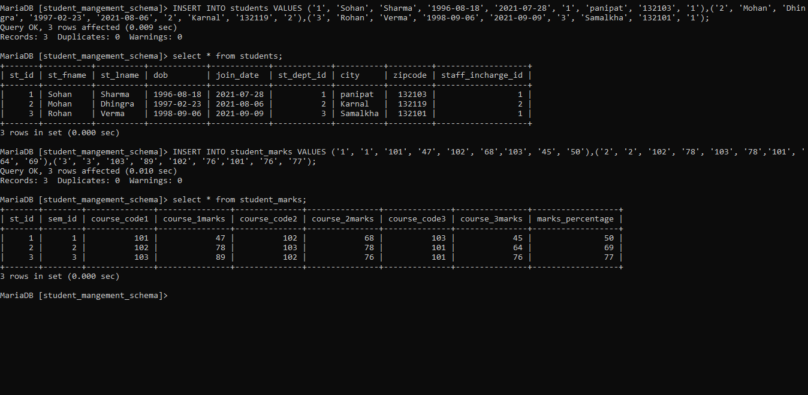

1. **Create view vw_placement with appropriate constraints data type, marks colum should only accept if the marks>80**

create view placement as

-> select s.st_id,s.st_fname,s.st_dept_id,m.marks_percentage as marks from students as s INNER JOIN student_marks as m ON s.st_id=m.st_id

-> where m.marks_percentage >80 ;



1. **Caluclate the marks_percentage in student_marks and update it respectively**

INSERT INTO student_marks VALUES ('2', '3', '103', '78', '102', '70', '101', '59');

select (course_1marks+course_2marks+course_3marks)/3 from student_marks;

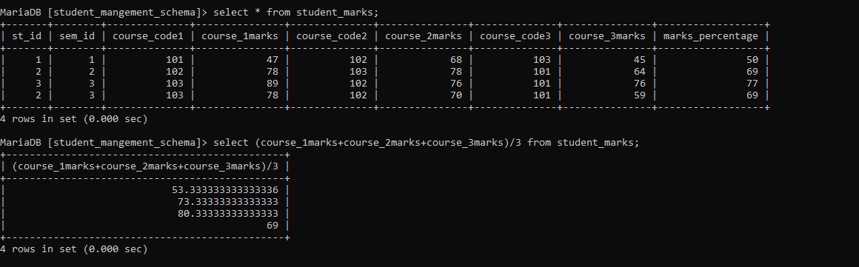

1. **Add new Staff_id in course_details and insert value respectively**

alter table course_details add column staff_id int after course_name;

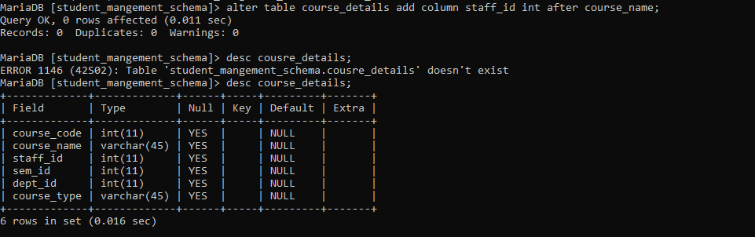

INSERT INTO course_details(`course_code`, `course_name`,`sem_id`, `dept_id`) VALUES ('104', 'English Speaking', '2', '3');

